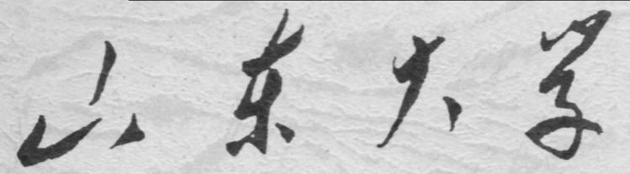

崇新学堂

2025－2026学年第一学期

实 验 报 告

课程名称： 电子信息工程导论
实验名称： A Real Head-Turner

专 业 班 级 崇新学堂
学 生 姓 名 高子轩，钱竹玉，吕思洁，徐亚骐
实 验 时 间 2025年11月21日

Pointing Circuit
Check Yourself 1: Complete and verify the circuit on the protoboard
This is the circuit we connected on the lab breadboard, modeled after the circuit in our simulation, with a resistance of 5Ω.
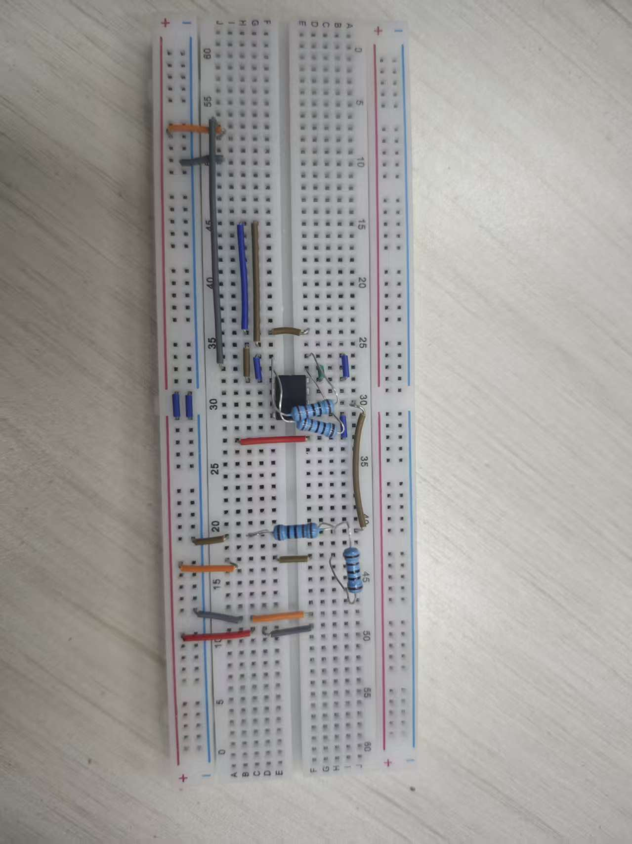
Figure 1 breadboard circuit
Connect the robot connector to the yellow cable coming from the robot. Connect the head connector to the front connector (near the eyes) of the head using a red cable.
Based on the above connection method, the physical diagram is roughly connected as follows
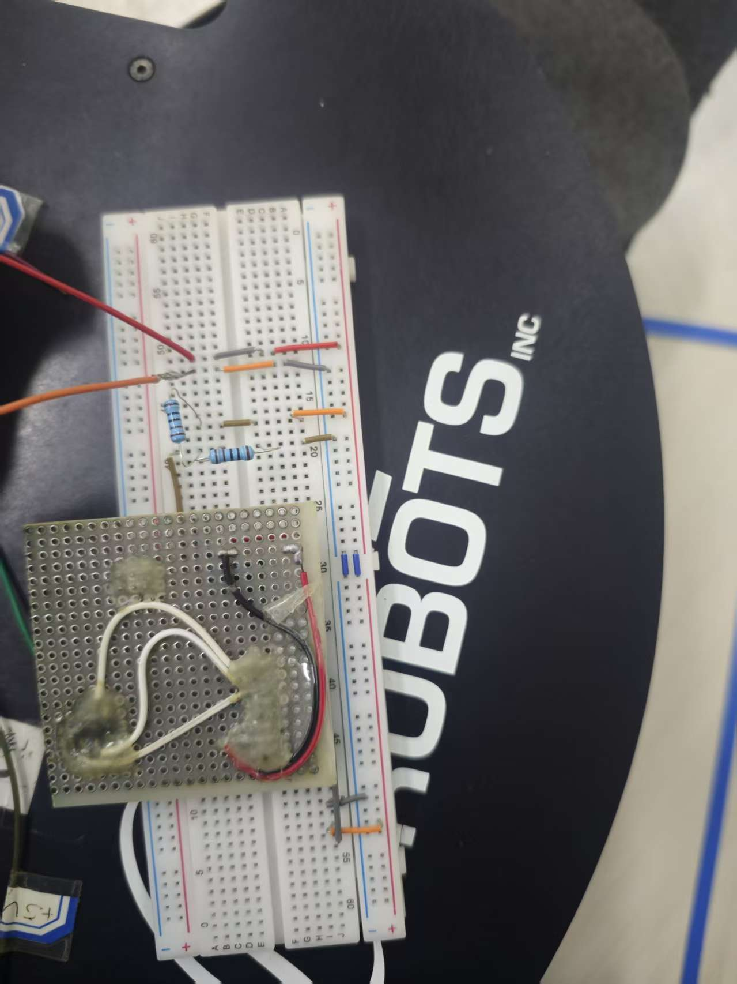
Figure 2 The general connection method of the physical object

Checkoff1: Illustrate the circuit and its performance at two different distances with the two gains.
Declaration:
Due to issues with the vehicle, we cannot obtain real data. We use simulation values for the following analysis and comparison.
The best $k_{s}$ is shown below
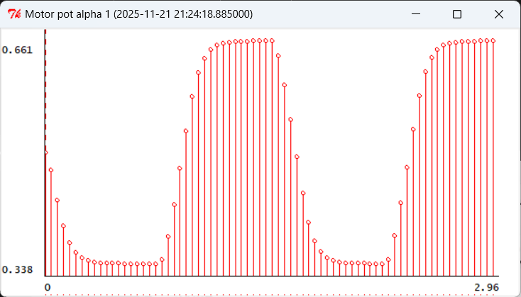
Figure 3 The best $k_{s}$ corresponding to the image
This is another gain, $k_{s}$
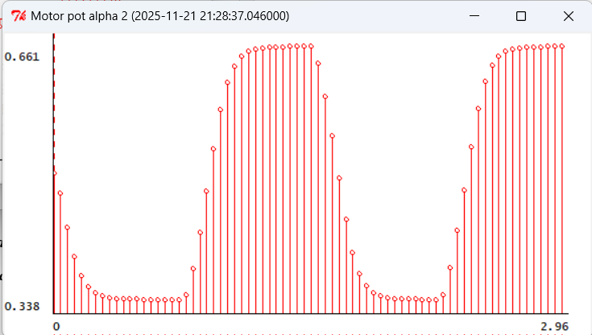
Figure 4 Images corresponding to $k_{s}$ in the control group
Our result(assumption):
Experimental results demonstrate that increasing either the gain $k_{c}$ or the distance-dependent sensor sensitivity $k_{s}$ accelerates the machine head's response speed, but simultaneously generates more overshoot and oscillation. As shown in the figure, our system currently exhibits some overshoot, indicating an under-damped state. When the distance is too close, resulting in a high $k_{s}$, oscillation intensifies and the stabilization time extends. Conversely, when the distance is too far, causing $k_{s}$ to be low, the response slows down, and the stabilization time increases due to delayed response.
Checkoff 2. Demonstrate the pointing accuracy of our head
Our strategy assumption:
To improve the accuracy, we need to make two improvements:
First, optimize the gain to maximize $k_{c}$ without causing oscillation, which can reduce the steady-state error.
Second, address the sensor mismatch issue by adjusting the fine-tuning resistors to compensate for the inherent differences between the left and right sensors.
Our explanation for the assumption:
The fundamental limitation of precision stems from the motor's dead zone. When the head approaches the target, the error signal becomes too weak, and the drive voltage fails to overcome the motor's static friction, causing the head to stop before fully aligning. Additionally, sensor noise further restricts the final precision.
Appendix1: Some content description
Since this experiment cannot be conducted on actual vehicles or through simulations, we have made numerous assumptions in the article, relying on intuition and conjecture to address certain questions.
Appendix2: The Description of AI Usage in the Report
Since real testing was not feasible, we employed AI to infer unknown scenarios in this experiment and responded based on its explanations.

